Assignment No:5
Name: Prutha Ranjit Sawale
Class: CS(AI)- B
Roll no.: 18
PRN: 12310272

Title: Client server programs using UDP Berkeley socket primitives.
Problem Statement: Write the client server programs using UDP Berkeley socket primitives for wired /wireless network for following a. to say Hello to Each other b. Calculator (Trigonometry).
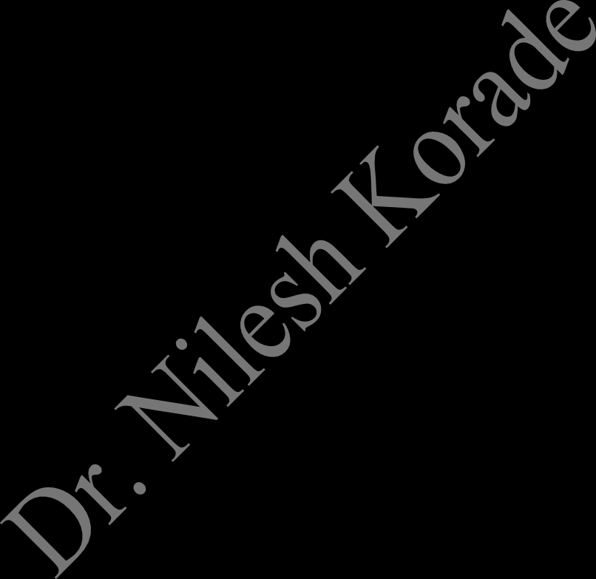
Course Objective: To learn transport layer and application layer protocols used in the Internet.
Course Outcome: Develop Client-Servers by the means of correct standards, protocols and technologies.
Tools Required: Eclipse, Java.

Theory:
- Introduction
The term network programming refers to writing programs that execute across multiple devices (computers), in which the devices are all connected to each other using a network.
The java.net package of the J2SE APIs contains a collection of classes and interfaces that provide the low-level communication details, allowing you to write programs that focus on solving the problem at hand.
The java.net package provides support for the two common network protocols:
- TCP: TCP stands for Transmission Control Protocol, which allows for reliable communication between two applications. TCP is typically used over the Internet Protocol, which is referred to as TCP/IP.
- UDP: UDP stands for User Datagram Protocol, a connection-less protocol that allows for packets of data to be transmitted between applications.

What is UDP?
UDP (User Datagram Protocol) is a connectionless, lightweight transport protocol that allows applications to send and receive datagrams without establishing a connection. It is faster but less reliable than TCP, as it does not guarantee delivery, ordering, or error checking.

Berkeley Sockets Model
The Berkeley Sockets API is a low-level network communication interface originally developed for UNIX systems. Java’s java.net package provides a high-level abstraction of Berkeley Sockets. In UDP communication, Berkeley Sockets provide:
    - No connection establishment: Send and receive packets independently.

    - Datagram-based communication: Each message is sent as an individual packet.
    - Best-effort delivery: No guarantee of packet arrival or order.

2.3 UDP Communication Flow in Java Server Side:
- Create DatagramSocket on a fixed port.
- Wait for incoming packets using receive().
- Read data from DatagramPacket.
- Optionally send a response using send().

Client Side:
- Create DatagramSocket.
- Create DatagramPacket with message and server details.
- Send message using send().
- Wait for reply using receive().

Java Classes Used in UDP (Berkeley Sockets Model)

Class Name | Package | Description
DatagramSocket | java.net | Used to send and receive UDP packets. It acts as the communication endpoint.
DatagramPacket | java.net | Represents a UDP datagram packet. Carries data to be sent or received.
InetAddress | java.net | Represents an IP address (IPv4 or IPv6). Used to specify sender/receiver host.
IOException | java.io | Handles input/output errors that may occur during socket  communication.
UnknownHostException | java.net | Thrown when IP address of a host cannot be determined (usually on client side).
SocketException | java.net | Thrown when there is an error creating or accessing a DatagramSocket.

Conclusion: Hence, we have Successfully wrote a client server programs using UDP Berkeley socket primitives for wired /wireless network to say Hello to Each other and Calculator (Trigonometry).

Program:
SERVER
import java.net.*; import java.io.*;

public class UDPServer {
public static void main(String[] args) throws Exception { DatagramSocket socket = new DatagramSocket(9001);
BufferedReader br = new BufferedReader(new InputStreamReader(System.in));

byte[] receiveBuffer = new byte[1024]; byte[] sendBuffer;

System.out.println("UDP Server started. Waiting for client..."); while (true) {
DatagramPacket receivePacket = new DatagramPacket(receiveBuffer, receiveBuffer.length);
socket.receive(receivePacket);
String clientMsg = new String(receivePacket.getData(), 0, receivePacket.getLength()); System.out.println("Client says: " + clientMsg);

if (clientMsg.equalsIgnoreCase("bye")) { System.out.println("Client ended the chat."); break;
}

System.out.print("Enter message for client: "); String serverMsg = br.readLine();
sendBuffer = serverMsg.getBytes();
InetAddress clientAddress = receivePacket.getAddress(); int clientPort = receivePacket.getPort();

DatagramPacket sendPacket = new DatagramPacket(sendBuffer, sendBuffer.length, clientAddress, clientPort);
socket.send(sendPacket);

if (serverMsg.equalsIgnoreCase("bye")) { System.out.println("Server ended the chat."); break;
}
}
socket.close();
}
}

CLIENT
import java.net.*; import java.io.*;

public class UDPClient {
public static void main(String[] args) throws Exception { DatagramSocket socket = new DatagramSocket();
BufferedReader br = new BufferedReader(new InputStreamReader(System.in));

byte[] sendBuffer;
byte[] receiveBuffer = new byte[1024];

InetAddress serverAddress = InetAddress.getByName("localhost"); int serverPort = 9001;

while (true) {

System.out.print("Enter message for server: "); String clientMsg = br.readLine();
sendBuffer = clientMsg.getBytes();
DatagramPacket sendPacket = new DatagramPacket(sendBuffer, sendBuffer.length, serverAddress, serverPort);
socket.send(sendPacket);

if (clientMsg.equalsIgnoreCase("bye")) { System.out.println("Client ended the chat."); break;
}

DatagramPacket receivePacket = new DatagramPacket(receiveBuffer, receiveBuffer.length);
socket.receive(receivePacket);
String serverMsg = new String(receivePacket.getData(), 0, receivePacket.getLength()); System.out.println("Server says: " + serverMsg);

if (serverMsg.equalsIgnoreCase("bye")) { System.out.println("Server ended the chat."); break;
}
}
socket.close();
}
}

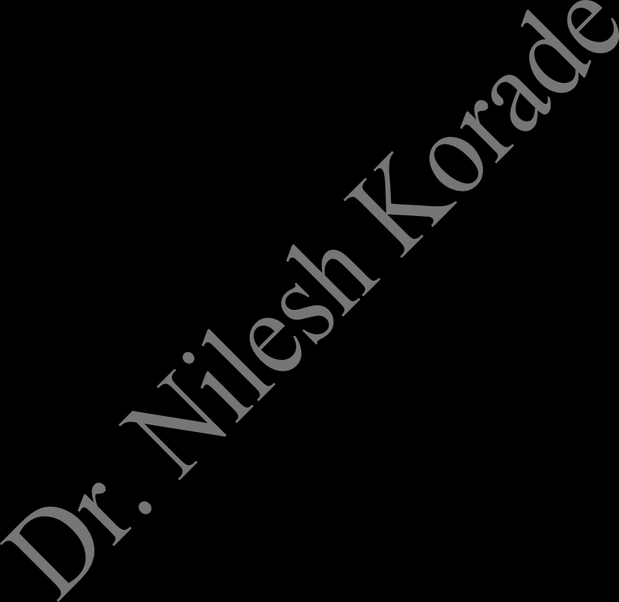
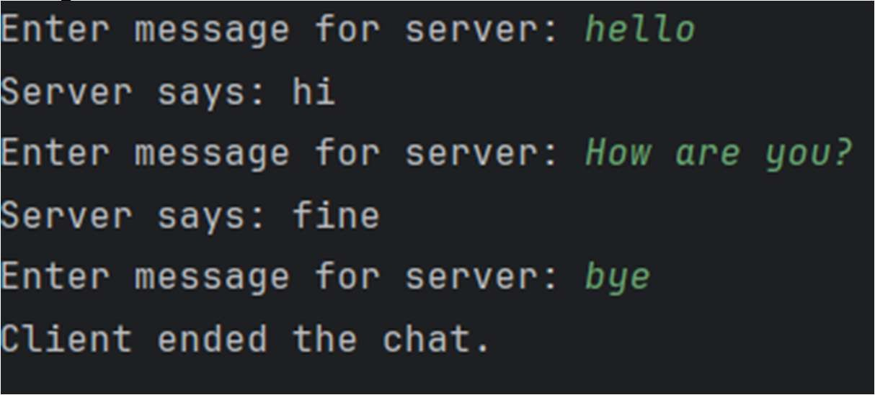
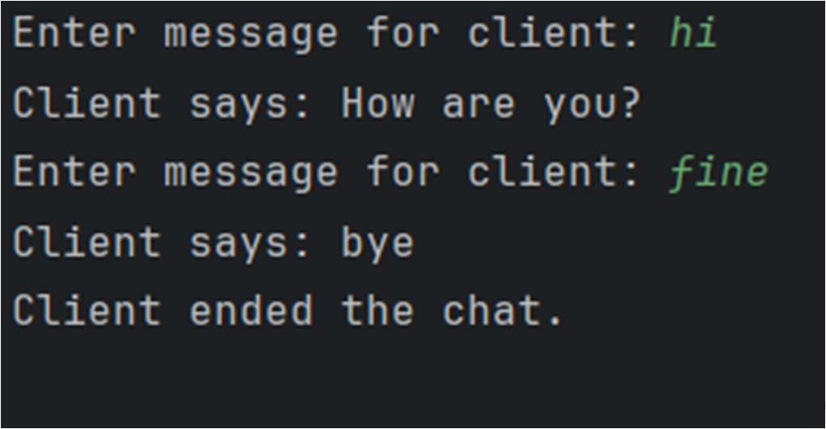
SERVER
Output:
import java.io.IOException; import java.net.*;
import java.nio.charset.StandardCharsets;

public class trigoServer {
private static final int PORT = 9876;
private static final int BUFFER_SIZE = 1024;
public static void main(String[] args) {
System.out.println("Starting UDP Trigonometry Server on port " + PORT + "...");

try (DatagramSocket serverSocket = new DatagramSocket(PORT)) { byte[] receiveBuffer = new byte[BUFFER_SIZE];

while (true) {
DatagramPacket receivePacket = new DatagramPacket(receiveBuffer, receiveBuffer.length);
serverSocket.receive(receivePacket);

String request = new String(receivePacket.getData(), 0, receivePacket.getLength(), StandardCharsets.UTF_8).trim();
InetAddress clientAddress = receivePacket.getAddress(); int clientPort = receivePacket.getPort();

String result = "Invalid input.";

String[] parts = request.split(" "); if (parts.length == 2) {
try {
String function = parts[0].toLowerCase(); double value = Double.parseDouble(parts[1]);

double calculatedValue = 0.0; switch (function) {

case "sin":
calculatedValue = Math.sin(Math.toRadians(value));
result = String.format("sin(%s) = %.4f", value, calculatedValue); break;
case "cos":
calculatedValue = Math.cos(Math.toRadians(value));
result = String.format("cos(%s) = %.4f", value, calculatedValue); break;
case "tan":
// Check for values where tangent is undefined. if (value % 180 == 90) {
result = "tan(" + value + ") is undefined";
} else {
calculatedValue = Math.tan(Math.toRadians(value));
result = String.format("tan(%s) = %.4f", value, calculatedValue);
}

break;

}
} catch (NumberFormatException e) {
result = "Invalid number format. Please provide a numeric value.";
}
}
byte[] sendBuffer = result.getBytes(StandardCharsets.UTF_8);
DatagramPacket sendPacket = new DatagramPacket(sendBuffer, sendBuffer.length, clientAddress, clientPort);
serverSocket.send(sendPacket); System.out.println("Sent response: " + result);
}
} catch (SocketException e) { System.err.println("Socket error: " + e.getMessage());

} catch (IOException e) {
System.err.println("I/O error: " + e.getMessage());
}
}
}

CLIENT

import java.io.IOException; import java.net.*;
import java.nio.charset.StandardCharsets; import java.util.Scanner;

public class trigonometryClient {

private static final String shost = "localhost"; private static final int sport = 9876;
private static final int buffersize = 1024; public static void main(String[] args) {
System.out.println("UDP Client started.");
System.out.println("Enter choice 'sin 90', 'cos 45', or 'bye' to exit."); try (DatagramSocket clientSocket = new DatagramSocket();
Scanner scanner = new Scanner(System.in)) {

InetAddress serverAddress = InetAddress.getByName(shost); byte[] receiveBuffer = new byte[buffersize];

while (true) {
System.out.print("Enter command: "); String command = scanner.nextLine();

if ("bye".equalsIgnoreCase(command)) { System.out.println("Exiting client."); break;
}

byte[] sendBuffer = command.getBytes(StandardCharsets.UTF_8); DatagramPacket sendPacket = new DatagramPacket(sendBuffer, sendBuffer.length,
serverAddress, sport);
clientSocket.send(sendPacket);
DatagramPacket receivePacket = new DatagramPacket(receiveBuffer,

Output:
receiveBuffer.length);
clientSocket.receive(receivePacket);

String serverReply = new String(receivePacket.getData(), 0, receivePacket.getLength(), StandardCharsets.UTF_8);
System.out.println("Server response: " + serverReply);
}
} catch (SocketException e) { System.err.println("Socket error: " + e.getMessage());
} catch (IOException e) {
System.err.println("I/O error: " + e.getMessage());
}
}
}

